**ALTO Treatment Protocols**

**MSK/BACK Pain**

*Note: This includes sprains, strains, or opioid-naïve lower back pain, acute neck, joint and soft tissue pain; rotator cuff tendonitis, arthritis of knee, lateral epicondylitis, greater trochanteric bursitis, biceps tendonitis, etc. Acute on chronic radicular lower back pain (opioid tolerant) can be approached in a similar manner.*

* Acetaminophen 1,000 mg PO OR 650 mg PR if unable to tolerate PO
* NSAIDs: Ibuprofen 600 mg PO OR Ketorolac 10 mg IV/15 mg IM
* Muscle relaxant: Cyclobenzaprine 5 mg PO OR Diazepam 5 mg PO OR Tizanidine 2mg PO OR Methocarbamol 500 mg PO
* Trigger-point injection with 1-2 mL of lidocaine 1%
* Gabapentin 300mg PO (if neuropathic pain)
* Lidocaine 5% patch to most painful area; instruct patient to remove after 12 hours
* Dexamethasone 4-10 mg IV
* Ketamine 0.2 mg/kg IVPB over 10 min based on IBW
* Ketamine 0.5 mg/kg intranasal x 1 dose (max = 50 mg)

**ALTO – Neuropathic Pain**

FIRST LINE TX:

* Acetaminophen 1000 mg PLUS Celebrex 200 mg po x 1 dose OR Ibuprofen 400 mg po x 1 dose

IF UNABLE TO TOLERATE PO THERAPY:

* Acetaminophen 650 mg per rectum x 1 PLUS Ketorolac 10mg IV x 1

ALTERNATIVES:

* Gabapentin 300 mg po x 1 dose
* Topical lidocaine 5% patch transdermal to affected area
* Naproxen 500 mg po x 1 dose

FOR REFRACTORY PAIN:

* Ketamine 0.2 mg/kg IVPB over 10 min based on IBW (max = 30 mg)

OR

* Ketamine 0.5 mg/kg intranasal x 1 dose (max 50 mg)
* Lidocaine 1.5 mg/kg IV IVPB diluted in 50 mL D5W x 1 over 30 minutes (max dose = 200 mg)

**ALTO - Renal Colic Protocols**

FIRST-LINE THERAPY

Ketorolac 10 mg IV or PO Ibuprofen if pt can tolerate 400-800mg

Acetaminophen 1,000 mg PO vs IV Ofirmev 650 mg – 1 gram over 15 minutes if cannot tolerate PO

1 L 0.9% normal saline bolus

SECOND-LINE IV THERAPY

Lidocaine 1.5 mg/kg IV of 2% cardiac lidocaine in 100 ml normal saline over 10-15 minutes (max 200 mg)

ALTERNATIVES

Ketamine 50 mg IN (Intra-Nasal) 0.5 mg/kg (concentration 100 mg/mL); (max 50 mg; max per nare 1 mL)

**ALTO – Lidocaine CONTRAINDICATIONS**

* Sensitivity or Allergy to Lidocaine
* Pregnancy
* Seizure Disorder
* Hepatic Insufficiency (Tbili > 1.46)
* Renal Insufficiency (CrCl < 30 or ESRD)
* Severe CAD or CHF/Cardiomyopathy w/ EF < 20%
* Hx of AV Block i.e. 2nd/3rd Degree AVB; Adams-Stokes; WPW; LGL; AVNRT
* Cardiac Dysrhythmias
* Concurrent treatment with Class I antiarrhythmics or amiodarone use < 3 months
* Acute porphyria
* *Provider Discretion: Cardiac monitoring during and 30 minutes post infusion especially in pts > 65 y/o, RBBB, LBBB known, 1st degree AVB

**ALTO - Migraine Algorithm**

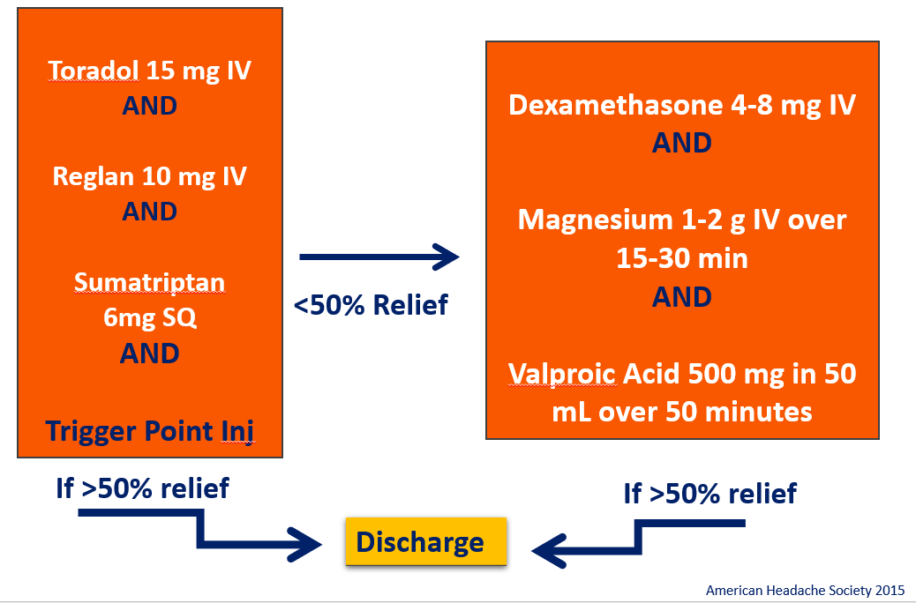

**ALTO – NON-SPECIFIC ABD PAIN**

FIRST LINE TX:

* Acetaminophen 1000 mg PLUS Celebrex 200 mg po x 1 dose OR Ibuprofen 400 mg po x 1 dose

IF UNABLE TO TOLERATE PO THERAPY:

* Acetaminophen 650 mg per rectum x 1 PLUS Ketorolac 10mg IV x 1

1ST LINE ALTERNATIVES OR IN ADDITION TO ABOVE THERAPY:

* Dicyclomine 20mg PO or 20mg IM
* GI Cocktail one dose PO
* Naproxen 500mg PO

REFRACTORY PAIN:

* Ketamine 0.2 mg/kg IVPB over 10 min based on IBW (max = 30 mg) OR

Ketamine 0.5 mg/kg INTRANASAL x 1 dose (max 50 mg)

**ALTO - GASTROPARESIS/CHRONIC ABD PAIN**

* Toradol 10-15mg IV/IM
* Metoclopramide 10mg IV
* Prochlorperazine 10 mg IV
* Diphenhydramine 25 mg IV
* Dicyclomine 20 mg PO/IM – if cramping component
* Haloperidol 2.5-5 mg IM/IV
* Lidocaine 1.5 mg/kg IVPB over 15 minutes (obtain from pharmacy)
* Ketamine 0.2 mg/kg IVPB over 10 min based on IBW

**ALTO – Sickle Cell Crisis Protocol**

* PO Ibuprofen-800mg OR IM (Intramuscular) Ketorolac 30mg OR IV Ketorolac 10mg
* IN INTRANASAL Ketamine 0.5 mg/kg (no more than 1ml per nostril, max 50mg) IF difficult IV Access
* IV Ketamine-0.2 mg/kg IVPB over 10 min based on IBW, then reassess, if still pain then + IV drip at 0.1 mg/kg /hr IBW infusion continuous until pain improved
* IV Lidocaine - 1.5 mg/kg IVPB over 15 minutes (obtain from pharmacy)

**ALTO – Dental Pain**

* Dental Blocks
* Ibuprofen 400mg – 800mg PO
* Acetaminophen 500mg – 1000mg PO
* Dental Referrals/Care Connect

**ALTO – Discharge/Outpatient Rx**

**Neuropathic Pain/Zoster/Peripheral or DM Neuropathy**

• Gabapentin 300 mg PO at bedtime

• Amitriptyline 25 mg PO at bedtime

• Pregabalin 75 mg PO 2x/day

**Undifferentiated Abdominal Pain**

• Dicyclomine 20 mg PO every 6 hour

• Ibuprofen 600 mg PO every 6 hours

• Acetaminophen 1,000 mg PO every 6 hours

• Metoclopramide 10 mg PO every 6 hours

• Prochlorperazine 10 mg PO every 6 hours

**Uncomplicated Back Pain**

• Acetaminophen 1,000 mg PO every 6 hours

• Ibuprofen 600 mg PO every 6 hours

• Lidocaine 5% transdermal patch every 24 hours (remove after 12 hours)

• Diclofenac 1.3% transdermal patch 2x/day **OR** diclofenac 1% gel 4 g 4x/day as needed

• Cyclobenzaprine 5 mg PO 3x/day or other muscle relaxant: Soma, Robaxin, Tizanidine

• Heat

• Physical therapy

• Exercise program

**Fibromyalgia**

• Cardiovascular exercise • Strength training • Massage therapy

• Amitriptyline 10 mg PO at bedtime

• Cyclobenzaprine 10 mg PO every 8 hours

• Pregabalin 75 mg PO 2x/day



**Special Populations**

Not all patients are appropriate candidates for each agent suggested in the ALTO treatment protocol. All medications should be administered with thoughtful consideration of patient-specific factors such as age, organ function, comorbidities and other medications being taken.

**Geriatric Patients**

Great care should be taken when treating elderly patients. Some of the therapies suggested may be inappropriate for use in this vulnerable population, including dicyclomine, haloperidol, diphenhydramine and muscle relaxants. The Beers Criteria list is a well-established resource that should be consulted when making treatment decisions for patients older than 65 years. When possible, consider prescribing topical agents instead of oral or intravenous drugs. Also consider recommending heat, massage and physical therapy on discharge for musculoskeletal pain.

**Renal Dysfunction**

Not all ALTO agents are safe for patients with renal dysfunction, particularly NSAIDs. In patients who cannot receive systemic NSAIDs, consider prescribing topical agents such as diclofenac gel or patches.

**Heart Failure**

Not all ALTO agents are recommended for use in patients with heart failure, particularly steroids and NSAIDs. For patients in whom these medications should be avoided, consider prescribing topical alternatives

**Pregnant Patients**

Pregnant women should be excluded from the ALTO protocol. Many of these agents are contraindicated in pregnancy, including haloperidol, NSAIDs, and valproic acid.

**Pediatric Patients**

Do not use the ALTO protocol when managing children younger than 15 years or less than 40 kg. Although ALTO principles are applicable to the pediatric population, precautions should be considered and agents must be dosed appropriately.

**Exclusions to ALTO**

* Rescue Opiate Analgesia:
  + Oxycodone 5 mg po x 1 dose
  + Morphine IR 15 mg po x 1 dose
  + Fentanyl IV x 1 dose
  + Morphine IV x 1 dose
* Provider discretion on when to utilize opiate medications
* Intractable pain from:
  + Advanced stage cancer
  + Trauma/Fractures
* Diagnosed surgical pathology: i.e. appendicitis, cholecystitis, bowel obstruction, ischemic bowel, etc.